Revision History
Date | Version | Description |  |  | Author
28/09/16 | 0.1.1 |  | Introduction to report and abbreviations are made, we decided on organization of the project. |  | İrem Toru, Zeynep İdil Utkusoy, Adem Tunay Saka
29/09/16 | 0.1.2 |  | Software development activities |  | Zeynep İdil Utkusoy, İrem Toru
02/10/16 | 0.1.3 |  | Added risk management, fixed typos |  | Zeynep İdil Utkusoy
03/10/16 | 0.1.4 |  | Added risk planning |  | Adem Tunay Saka
05/10/16 | 0.1.5 |  | Added Gannt Chart |  | Sena Odabaşı
06/10/16 | 0.1.6 |  |  | Changed the mentioned parts according to the first feedback | Zeynep İdil Utkusoy, Sena Odabaşı
11/10/16 | 0.1.7 |  |  | Changed parts 2.1.1 and 2.1.2 according to feedback. | İrem Toru

TABLE OF CONTENTS

Revision History 1
1 Identification 3
1.1 Document overview 3
1.2 Abbreviations 3
1.2.1 Abbreviations 3
1.3 References 3
1.3.1 Project References 3
2 Software Development Activities 3
2.1 Software development process 3
2.1.1 Technical documentation 4
2.1.2 Deliverables: 4
2.1.3 Workstation 4
2.1.4 Requirements management and documentation 4
2.1.5 Software Design 4
2.1.6 Coding and automated tests 4
2.1.7 Configuration management 4
2.2 Software development rules and standards 5
3 Responsibilities 5
3.1 Activities and responsibilities 5
4 Risk Assessment 5
4.1 Risk Analysis 5
4.2 Risk Planning 5

Identification

Document overview
This document contains the software development plan of software “Brick Breaker”.
This part of the report describes the software development of the BB software development. This program is written in Java language. This project is an application of the well-known game Brick Breaker with some differences. The user will try to break all of the bricks using the ball and the paddle, if the ball falls by not intersecting the paddle, the user loses. The game gets faster as the game continues; also game score is printed after the game ends.

Abbreviations

Abbreviations
ABBREVIATIONS | MEANING
BB | BrickBreaker
SDP | Software Development Plan
SRS | Software Requirements Document
STP | Software Test Plan
SDD | Software Design Document
STR | Software Test Report
UML | Unified Modeling Language

References

Project References

# | Document Identifier | Document Title
- | - | -

Software Development Activities
The section lists and describes the software development activities of BrickBreaker software development project.

Software development process
The software development process chosen for the project is the waterfall, because BB software development is a well-studied development.

Overview of process phases
The lifecycle of the software development project is composed of:
- Software specification,
- Software detailed design,
- Software coding and unit tests,
- Software integration
- Software verification tests

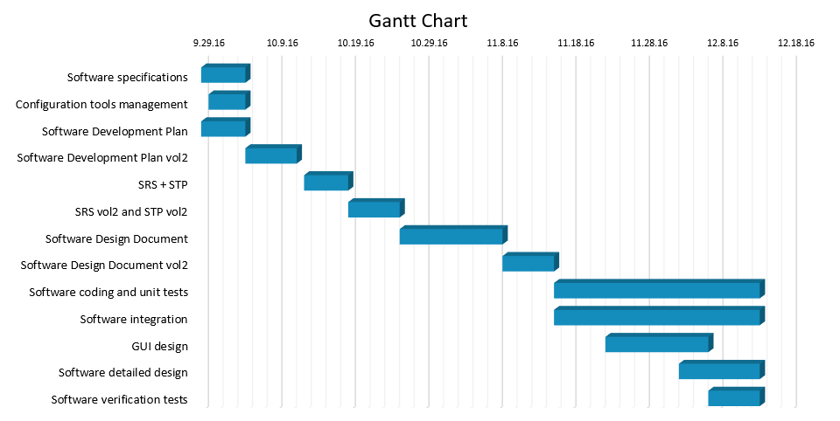

Technical documentation
→SDP
→SRS
→STP
→SDD
→STR
→Microsoft Word report

Deliverables:
→ GitHub project repository

Workstation
4 Laptops
- 1 Mac OS X 2.7 GHz Intel Core i5 8 GB
- 1 Mac OS X 2.6 GHz Intel Core i5 8 GB
- 1 Windows 2.00 GHz Intel Core i7 8GB
- 1 Windows 1.70 GHz Intel Core i7 6GB

Requirements management and documentation
→ Microsoft Word
→ Microsoft Excel

Software Design
→ Eclipse
→LucidChart UML

Coding and automated tests
→Eclipse
→ GitHub

Configuration management
→GitHub

Software development rules and standards
→ UML

Responsibilities

Activities and responsibilities
Each activity has someone responsible, mandatory.
Activity | Responsibility | Comment
Project management | Zeynep Idil Utkusoy | Organizes the distribution of roles, meetings
Configuration tools management | Irem Toru | Owner of the project account in GitHub
Setting up the Development tools | Sena Odabaşı, Irem Toru | Setting up the required tools for the development.
Software specifications | Sena Odabaşı İrem Toru, Zeynep İdil Utkusoy, Adem Tunay Saka
GUI design | Adem Tunay Saka | Designs the GUI

Risk Assessment

Risk Analysis
Risk | Probability | Effects
The time required to develop software is underestimated | Moderate | Serious
Key staff may be ill and be unavailable at critical times | Moderate | Tolerable
It could be hard to manage a meeting that fits every group members schedule | High | Tolerable
There may be some conflicts in the group, since we're not familiar with each other. | Moderate | Tolerable
Software tools may not be working together in a integrated way. | Moderate | Serious

Risk Planning
Risk | Strategy
Timing Problems | Prepare a schedule giving information about team members’ responsibilities in a specific time range to be able to implement the project on time.
Staff Illness | Get information about each team members’ illnesses and choose places to work in order to make team members feel alright. Also, the university management provides team members an infirmary in case of staff illnesses.
Organizational Problems | Get the necessary information about each team members’ schedules. Use social media to be informed about the the times that the team members are able to work and specify meeting times that fits every members’ schedules.
Team Members’ Problems | Organize meetings apart from the implementation of the project to make team members get to know each other and provide accordance in team.
Tool Problems | Make a research about the tools to be used in the implementation of the project and be sure whether those tools can work in an integrated way.

